RELATIONAL DATABASE MANAGEMENT SYSTEM

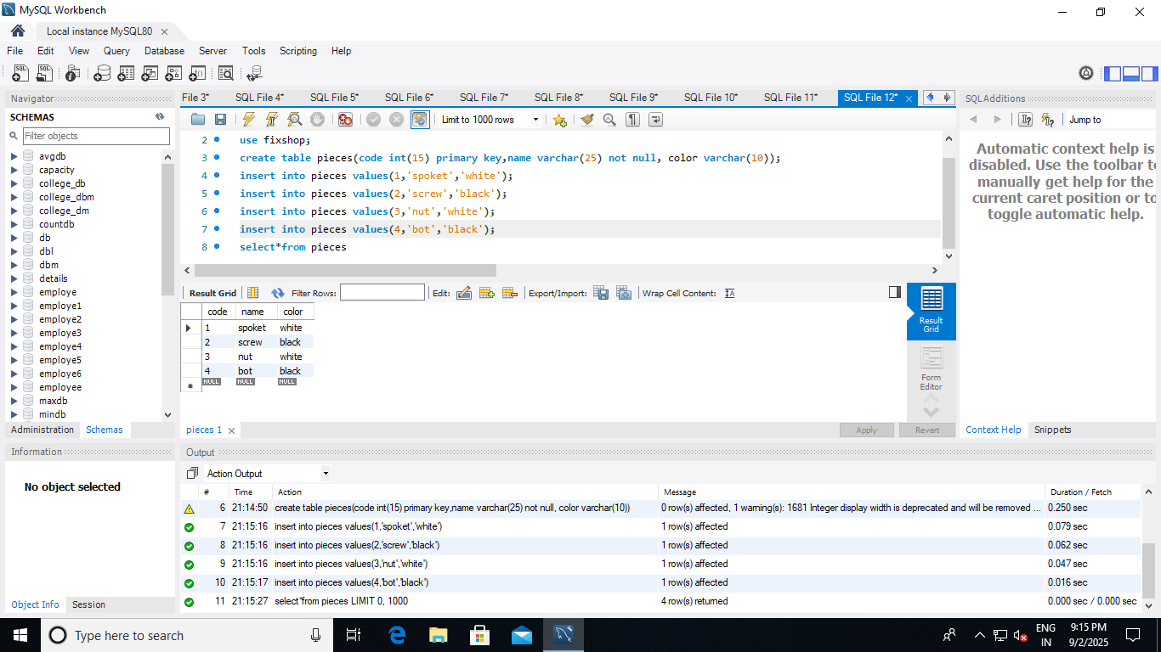 ASSIGNMENT-1